Tandy 1000 EX/HX
3-in-1 Upgrade
Owner’s Guide

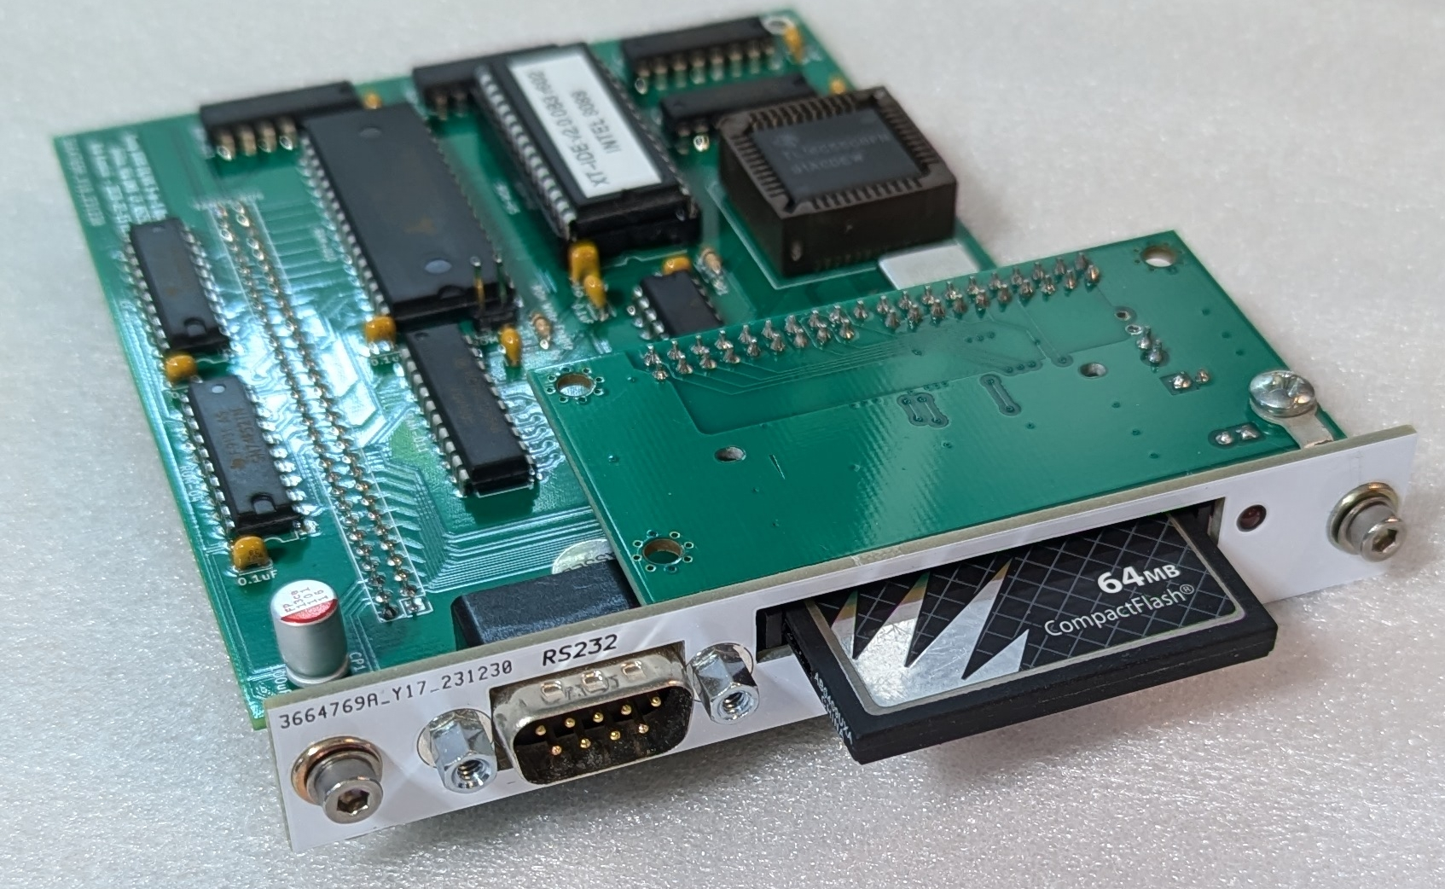

Last Revised July 2024
CONTENTS
INTRODUCTION 3
Description 3
Memory 3
Serial Port 3
XT-IDE 3
Compatibility 4
INSTALLATION 5
Configuration 5
Installing the 3-in-1 Upgrade 6
OPERATION 9
Memory 9
XT-IDE 10
Serial Port 10
COMPONENT LIST 12
WARRANTY 13
ABOUT THIS GUIDE
The information found in this guide has been compiled with the utmost attention to detail. However, this does not guarantee complete accuracy. This guide is provided ‘As Is’ and may contain technical inaccuracies or typographical errors. Any references in this document to other companies, products, or services are provided for convenience only and do not in any way serve as an endorsement or recommendation. Companies, products, or services identified throughout this document may be trademarks or service marks of others. All rights reserved.

This product is derived from the ‘Tandy-EX-HX-3in1’ project created by the user ‘rkrenicki’, Rob Krenicki. Rob’s original GitHub repository can be found here: https://github.com/rkrenicki/Tandy-EX-HX-3in1
Rob’s Tindie shop can be found here: https://www.tindie.com/stores/rkrenicki/

Details on this project, including up-to-date versions of this document, can be found here: https://github.com/leadacid44/Tandy-EX-HX-3in1






INTRODUCTION
Thank you for purchasing the Tandy 1000 EX/HX 3-in-1 Upgrade!

Description
The Tandy 1000 EX and HX systems originally came with just 256Kb of system memory, no serial ports, no hard drive, and a non-standard expansion slot. These limitations have made the EX and HX somewhat unattractive for the modern vintage computer enthusiast. While there were contemporary ways to expand the system’s capabilities, such upgrades were somewhat uncommon and are difficult to obtain today. The Tandy 1000 EX/HX 3-in-1 Upgrade overcomes these limitations by providing the following features:
- Fully expanded system memory - 640Kb conventional + 96Kb UMB
- Standard DB9 RS232 Serial Port
- XT-IDE ‘CF Lite’ Interface

Memory
The 3-in-1 Upgrade uses an Alliance AS6C4008 4Mbit static random access memory (SRAM) chip to provide an additional 512Kbytes of system memory. In combination with the original 256Kb of system memory, your computer will now have 768Kb of memory configured as 640Kb of conventional memory, plus an additional 96Kb of UMB (Upper Memory Block) memory.

Serial Port
The 3-in-1 Upgrade uses a Texas Instruments TL16C550 UART to provide a standard 16550-based, DE9 serial RS-232 port. This port is configured as ‘COM1’ and is capable of communications of up to 115kbit/s. The serial port is perfect for a serial mouse or communications with other systems.

XT-IDE
The 3-in-1 Upgrade implements a “XT-CF-lite rev.2” style XT-IDE adapter, which provides the standard XT-IDE Universal BIOS and a CompactFlash socket that is accessible from the rear of your computer. A bootable pre-formatted CompactFlash card has been included with your 3-in-1 Upgrade, which has been formatted with a minimal version of FreeDOS 1.3, and has been tested and verified as working with your adapter. A series of helpful utilities and example configurations for your Tandy 1000 EX/HX are also included on the card. This card will help you verify that the 3-in-1 adapter is functional, as well as aid in the process of installing the operating system of your choice.

Compatibility
The 3-in-1 Upgrade is only compatible with the Tandy 1000 EX or Tandy 1000 HX. The upgrade is not compatible with any other PLUS slot expansion adapters and must be the only adapter installed - all other adapters must be removed. Physically, the upgrade will take ‘Slot 2’ on the rear of your computer. Slots 1 and 3 will be unavailable for use.

The upgrade’s CompactFlash interface is generally compatible with all CompactFlash cards, however there are a wide variety of cards available, so not all cards may work the same, or at all. Generally it is recommended to use a CompactFlash card smaller than 256MB. It is generally not recommended to use MicroSD-to-CF card adapters, nor MicroDrive style cards. For more details on compatible cards, consult the XT-IDE project documentation.

The 3-in-1 Upgrade is compatible with both the Tandy 1000’s original Intel 8088 CPU, as well as the NEC V20 CPU. The 3-in-1 Upgrade ships with the standard XT-IDE R602 BIOS which is compatible with both CPUs, but an optional enhanced BIOS is available specifically for the NEC V20 CPU, which can improve disk performance. Contact your dealer for more information.

INSTALLATION
Your 3-in-1 Upgrade was tested and inspected prior to shipping, and found to be free of mechanical and electrical defects. Please take a moment to inspect the product for any damage that may have occurred in transit. Save all packing materials until installation is complete. If damage is found, contact your dealer before proceeding.
Contents
Your Tandy 1000 EX-HX 3-in-1 Upgrade package will contain:
- Tandy 1000 EX-HX 3-in-1 Upgrade board
- 64MB Compact Flash Card
- 2x M3 Retention Screws + Washers
- This documentation
If you do not have each of these items, contact your dealer before proceeding.

You will need to provide:
- 2.5mm Hex (Allen) Screwdriver
- #2 Phillips Screwdriver

Configuration
The 3-in-1 Upgrade board requires no additional configuration for normal operation, and is ‘plug and play’. There is one jumper, ‘J1’, which controls whether the XT-IDE EEPROM is in ‘Write Enable’ mode. The default is for the jumper to be open (removed) to disable writes. Unless you plan to write to the EEPROM, such as for on-system XT-IDE updates, it is strongly recommended that this jumper be left open.
Jumper | EEPROM  Write Enable | EEPROM  Write Disable
JP1 | CLOSE | OPEN *

Installing the 3-in-1 Upgrade

Warning: Internal components of the computer, as well as the 3-in-1 Upgrade board itself, are sensitive to static discharge. Follow the usual static discharge handling rules: don’t perform work in carpeted areas, don’t excessively handle components, limit your moments around the room, ground yourself by touching an earthed metal object before work, etc.

Caution: Shock hazards may exist within the computer. Do not open the cover unless you have unplugged the system from all electrical sources.

- Turn off power to the computer and all peripherals (display, printer, etc.)
- Disconnect all peripherals from the computer and disconnect the computer from all electrical sources.
- Using the 2.5mm hex screwdriver, remove the two included M3 socket head screws and washers from the 3-in-1 Upgrade board and set aside for later.
- If installed, remove the included CompactFlash card and set aside for later.
- Orient the computer such that the rear of the computer facing you. Remove the plastic option cover located on the top panel by pressing down on the edge nearest the front of the computer to disengage the hook-latch, and then slide the cover toward you.
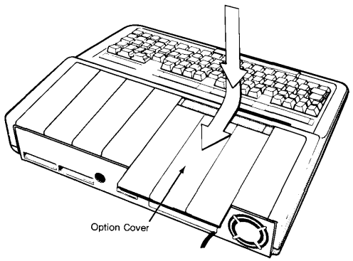Figure 1: Remove Option Cover
- If installed, remove any previously installed PLUS option boards from the computer. The 3-in-1 Upgrade board cannot be installed with other option boards.
- Remove all option slot covers on the rear panel of the computer by removing the #2 Phillips screws.
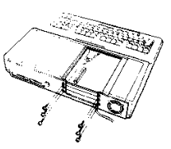Figure 2: Remove screws
- If necessary, break apart the rear panel’s breakaway-type slot cover into individual segments, and reattach the lowest slot cover segment.
- Ensure that the pin header on the computer’s main logic board is clean and free of dust or debris. Clean the pin header if necessary.
- Carefully align and lower the 3-in-1 Upgrade board pin socket onto the pin header on computer’s main logic board. Press gently only on the area surrounding the pin socket to prevent excessive flexing of the upgrade board. The faceplate of the 3-in-1 Upgrade board will be flush with the inside rear of the computer and will populate the middle slot. Align the screw holes.

Note! When the upgrade board is seated, check that all pins are fully inserted into the socket and that the board is parallel to the main logic board. Do not use excessive force. The shroud on the main logic board pin header will help align the pin connectors. It may be necessary to gently lift the upgrade board slightly to align the mounting screw holes of the faceplate with the rear of the computer.

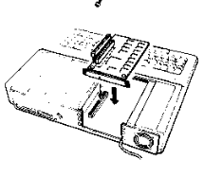Figure 3: Insert upgrade board
- Reinstall the M3 socket head screws and washers into the 3-in-1 Upgrade board snugly. Do not overtighten.
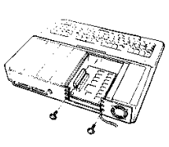Figure 4: Reinstall screws
- Reattach another segment of the breakaway slot cover into the topmost slot.
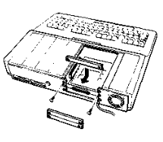Figure 5: Reinstall slot cover
- Replace the option cover by sliding it forward until it snaps into place.
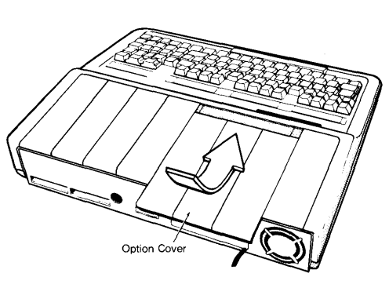Figure 6: Replace Option Cover
- Reinsert the CompactFlash card into the 3-in-1 Upgrade board. The front face of the card should be orientated up.
- Installation is complete.

OPERATION
Operation of the 3-in-1 Upgrade board in your Tandy 1000 is almost entirely automatic. No specific configuration of the board is necessary for normal functionality, however a few quality-of-life changes can be made to improve operation of your computer with the 3-in-1 Upgrade.

Memory
The 3-in-1 Upgrade will automatically increase the computer's conventional memory to 640Kb. On power up, the computer will display “Memory Size = 640k” on the screen, indicating that the upgrade is properly connected and functional. No other action is required to use this additional memory.

Note! If the computer does not display 640k of system memory at system power on, or there appears to be other problems with the upgrade, power off the computer and confirm that the upgrade board is properly seated. If you continue to have problems, consult your dealer.

An additional 96Kb of UMB (Upper Memory Block) memory is provided by the 3-in-1 Upgrade, but most versions of DOS are unable to take advantage of this memory directly. The included CompactFlash card has example configurations for using the ‘DOSMAX’ utility to move MS-DOS into this UMB, freeing up additional conventional system memory. Typical MS-DOS 5 configurations using DOSMAX can yeild 624Kb of conventional memory available for user programs. Should you wish to use this utility, examine the example configurations and implement as necessary for your situation.

Historically, memory upgrades for the Tandy 1000 EX / HX (such as Tandy’s ‘Memory PLUS Expansion Adapter’ P/N 25-1062) provided an additional Direct Memory Access (DMA) controller to handle (among other things) the refresh timing for the adapter’s added DRAM memory. As the 3-in-1 Upgrade uses SRAM, which does not have such refresh requirements, the DMA functionality is not needed. The presence or lack of DMA does not impact performance of most aspects of using the system.

XT-IDE
The 3-in-1 Upgrade provides a “XT-CF-lite rev.2” style XT-IDE adapter, providing the standard XT-IDE Universal BIOS and a CompactFlash socket that is accessible from the rear of your computer. The XT-IDE ROM is mapped to the 0xC000 address, and the CF socket to the 0x300 address. Version ‘R602’ of the XT-IDE software is programmed into the EEPROM. Operation of the XT-IDE software and interface is the same as any standard XT-IDE implementation, so it is recommended to reference the official XT-IDE documentation for specific operational instructions.

When installed in a Tandy 1000 EX, the XT-IDE software will start automatically. When installed in a Tandy 1000 HX, the XT-IDE software will not necessarily start automatically, but instead follow the existing configured boot order. By default, the HX will boot the built-in system ROM containing Tandy MS-DOS v2.11, and then either load the command prompt, load a menu, or load Personal DeskMate. The Tandy ‘SETUPHX.COM’ program can change this behavior, and a copy is included on the provided CompactFlash card for your convenience. If your system boots to the menu, press the F4 key for ‘Startup from Internal Drive’ and the XT-IDE software will load. If you want the XT-IDE software to load every time, run the setup program and change the ‘PRIMARY START-UP DEVICE’ setting to ‘DISK’.

The 3-in-1 Upgrade board has a single jumper ‘JP1’ which enables writes to the EEPROM for future XT-IDE software upgrades. The jumper should be left removed for normal operation.

Serial Port
The 3-in-1 Upgrade places a serial port on the typical I/O address 0x3F8 and IRQ 4, which the computer will automatically detect. MS-DOS, in turn, will see this serial port and assign it the label COM1. System information programs like Norton System Info will indicate if the system has detected the serial port.
The serial port address and IRQ configuration is hard-wired and cannot be changed. Serial port settings are under software control, and must be initialized for correct baud rate, parity, etc.

COMPONENT LIST

Description | Qty | Location | Mouser PN
PCB | 1 | N/A | N/A
Back plate | 1 | N/A | N/A
2x31 2.54mm Header Socket | 1 | BUS1 | 200-CES13101SD
2x20 2.54mm Header Socket, 11mm height | 1 | CF-J1 | 517-8540-4500PL
10kOhm Resistor, 1/10w or 1/8w | 4 | R1-R4 | 603-CFR-12JT-52-10K
0.1uF Multilayer Ceramic Cap, 2.5mm | 6 | C1-C16 | 594-K104M15X7RF53L2
47-100uF 6.3-16V Cap, 2.5mm | 1 | CP1 | 647-RNU1C101MDS1
1.8432Mhz 1/2-size Oscillator | 1 | 232-OSC1 | 774-MXO45HS-3C-1.8
DE9 Male Right Angle Connector | 1 | 232-P2 | 806-K22X-E9P-N-99
Jackscrew for DE9 connector | 2 | 232-P2Screw | 571-5207953-3
GD75232N RS232 Driver | 1 | 232-U6 | 595-GD75232N
74LS138 3-to-8 Line Demux | 2 | 232-U7,232-U9 | 595-SN74LS138N
16550/16C550 UART in PLCC-44 Package | 1 | 232-U8 | 701-ST16C550CJ44TR-F
PLCC-44 Through Hole Socket | 1 | 232-U8Socket | 517-8444-11B1-RK-TP
1x2 2.54mm Header Socket | 1 | CF-J2 | 200-CES10101TD
74LS139 Dual 2-to-4 Demux | 1 | CF-U1 | 595-SN74LS139AN
74F521 8-bit Comparator | 2 | CF-U2,ROM-U4 | 595-SN74F521N
74LS245 Tri-state Bus Transceiver | 2 | CF-U3,RAM-U11 | 595-SN74LS245N
AS6C4008-55PCN 4mbit (512k x 8) Static RAM | 1 | RAM-U10 | 913-AS6C4008-55PCN
74LS00 Quad NAND Gate | 1 | RAM-U12 | 595-SN74LS00N
74LS32 Quad OR Gate | 1 | RAM-U13 | 595-SN74LS32N
28C64 64k x 8 EEPROM | 1 | ROM-U5 | 556-AT28C64B15PU
28-pin Wide DIP Socket | 1 | ROM-U5Socket | 517-4828-6000-CP
CF to IDE Adapter | 1 | CF-IDEAdapter | N/A
Mounting Tab for Backplate | 1 | J1 | 534-7327
64MB CF Card | 1 | N/A | N/A
M3 Rivet Nut | 2 | N/A | N/A
M3 Screw + Washer | 2 | N/A | N/A

All 74LSxx series logic ICs can be substituted with any family with "LS" or "T" in the name, such as 74ALSxx, 74ACTxx, 74AHCTxx, or 74HCTxx, etc.

This board is designed to use a specific CF to IDE adapter widely available on eBay. It usually has the mark "IDE to CF Ver.D2", fits into an expansion card slot, can can generally be identified by the metal cover over the CF card connector itself. The metal expansion slot plate is removed and a small modification is required to the power connector to make it usable with the 3-in-1 Upgrade.

WARRANTY
No warranty or guarantee of any kind is expressed or implied. Not liable for consequential damages. Returns are not accepted. Use of the 3-in-1 Upgrade is entirely at your discretion and risk. Misuse, accidents, modification, improper handling, etc. are entirely up to you.

Every 3-in-1 Upgrade is manufactured from new parts, or new and serviceable used parts which perform like new parts. Every adapter is tested to be free from defects in materials and workmanship.

However, this is an aftermarket part made for a 1980’s computer by a guy in a shed. If you’re worried that this may damage up your computer, perhaps its not for you. If you have any questions, contact your dealer.

Proudly Made in Wisconsin!

